Practical No: 12

**Aim:** Installing Windows 10 IoT core on Raspberry Pi.

**Hardware Required:**

1. Raspberry Pi 3B+
2. Ethernet Cable
3. Monitor
4. HDMI to VGI convertor
5. Micro SD card (any class best is class 10)
6. Adaptor with 5v 2A
7. USB mouse
8. USB keyboard

**Software Required:**

1. IoT Dashboard (Windows Executable Software)

**Procedure:**

1. Insert a SDCard reader with class 10 SD card and format it.
2. Download IoT Dashboard software from <https://docs.microsoft.com/en-us/windows/iot-core/downloads> and execute in the PC.
3. In Setup new Device Tab provide an Administrator Password.
4. Accept the software license terms by ticking the check box.
5. Click on Download and Install, click Continue.

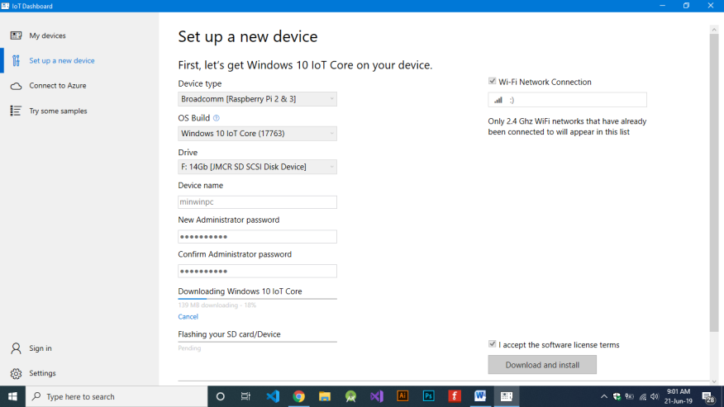

1. On Completion You will get a screen like this…

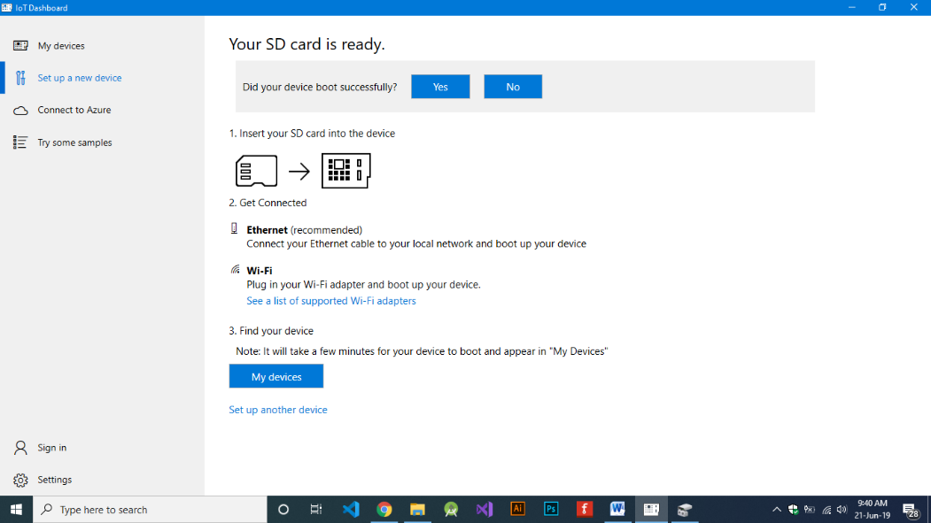

1. Put the SD card into raspberry pi and provide power after connecting keyboard, mouse, monitor etc.